SECSR2043 OPERATING SYSTEMS
[20 Marks]

Name | : | LING YU QIAN |  |  |  | Marks
Student ID | : | A23CS0301
Section | : | 7

Instruction: Please answer all of the following questions. Whenever the symbol appears, please raise your hand to call your instructor, he/she will verify your results by putting his / her initial next to the symbol.

- Type the following commands using a text editor and save it as a yourname.sh (Example: ahmad.sh).
echo “Hello world” > helloworld.jar
mkdir cars; mkdir dates; mkdir fruits drinks
cd cars; echo “Honda Accord” > accord.c
cp accord.c civic.c; echo proton > proton.c; cd ../dates;
date > dateoftheday
cat dateoftheday > appointment
cd ../fruits; echo apple > apple.txt; cat apple.txt > orange.txt
cd drinks; cp ../cars/*.* .; cp ../fruits/*.* .;
cp ../*.jar .

  - Execute the script and draw a tree structure that contains created directories and files. The parent node of the directory begin with $HOME directory. [4 marks]

$HOME

Print screen the script that you type;
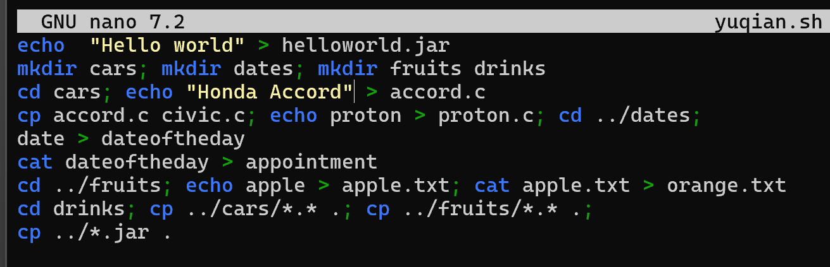

Then draw the tree
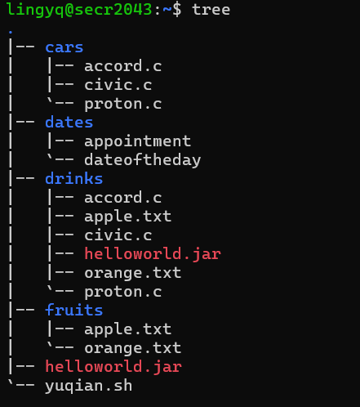

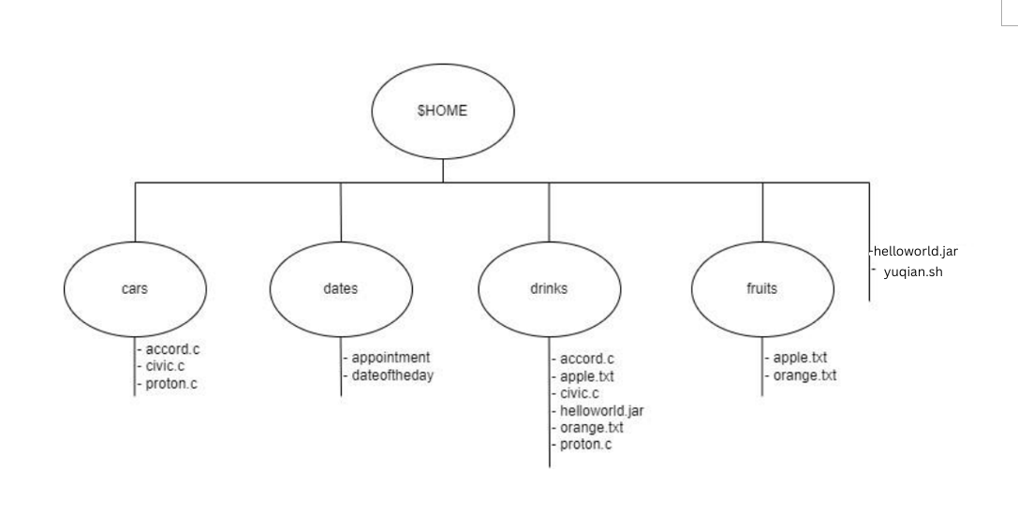

  - Write an interactive bash script that will read a type of file extension, display all those files, and count the number of files. To validate your script, display c program files, and enter “c” as the input to the bash script. [4 marks]
Print screen the bash script you type and run
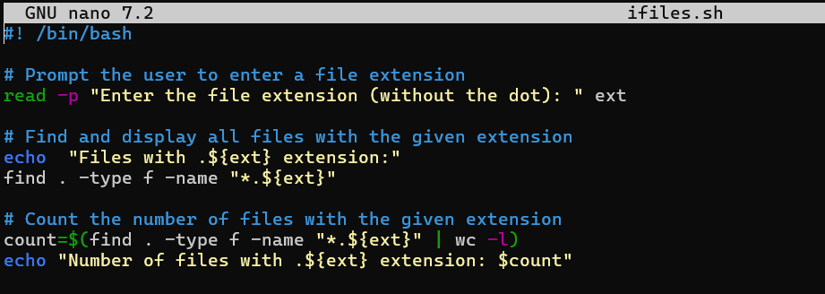

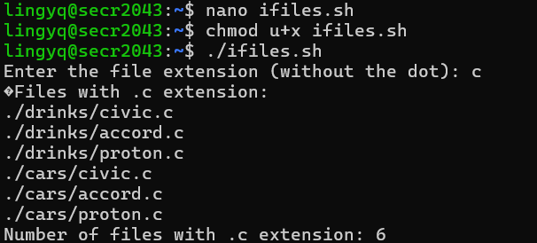

- The following Figure 1 illustrates a tree structure of some directories and files.
$HOME
subjects
faculties
books
- operating_systems
- software_engineering
- data_communication
FCS
FBE
- Linux_operating_systems
- Best_of_software_engineering

- dean
- deputy_dean
- Project_Manager
Directory

Text Files

  - Write a bash script (called myname2a.sh) that will produce directories and files as in Figure 1. Each text files contain its filename without the underscore character. For example: text file Project_Manager contains Project Manager). [4 marks]

Print screen the bash script you type and run
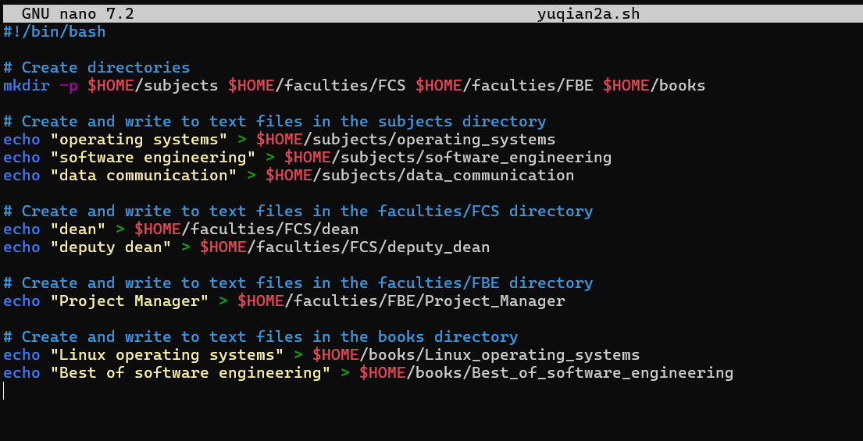
Print screen the bash script you type and run
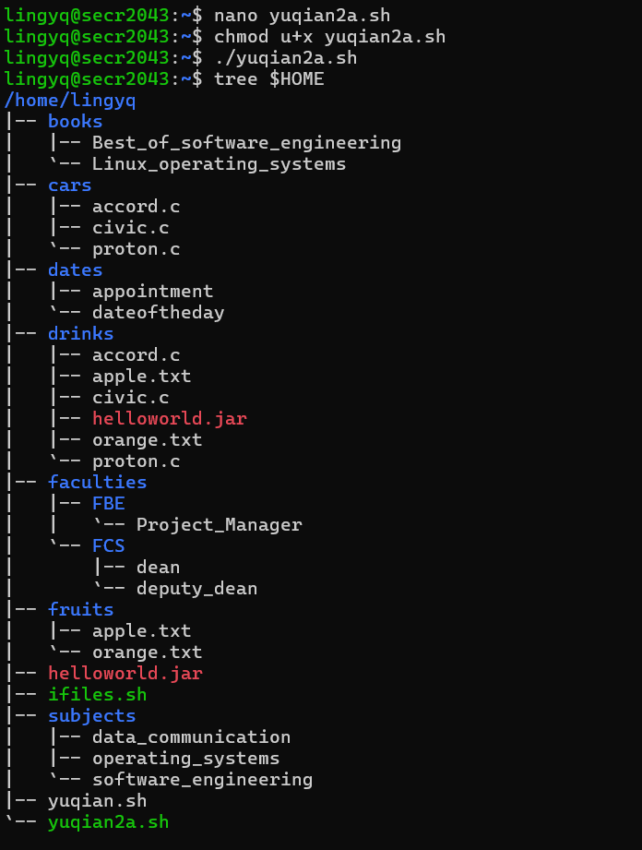

  - Complete the following table by writing the access control of directories or files that were produced. Given is the access control for directory called book. [2 marks]

Directory/File | Access Control
books | drwxrwxr-x
subjects | drwxr-xr-x
Best_of_software_engineering | -rw-r--r--
FCS | drwxr-xr-x
project_manager | -rw-r--r--
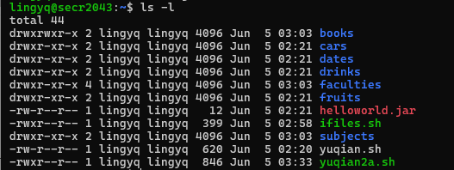

  - Write another bash script (called myname2c.sh) that will change the access control of the directories and files based on the following information: [4 marks
Directory/File | Users
 | Owner |  |  | Group |  |  | Public
subjects |  |  |  |  | x | x |  | x | x
Best_of_software_engineering |  | x |  | x |  | x | x | x | x
FCS |  |  | x | x | x | x
project_manager | x | x | x | x |  |  | x | x

Print screen the bash script you type and run
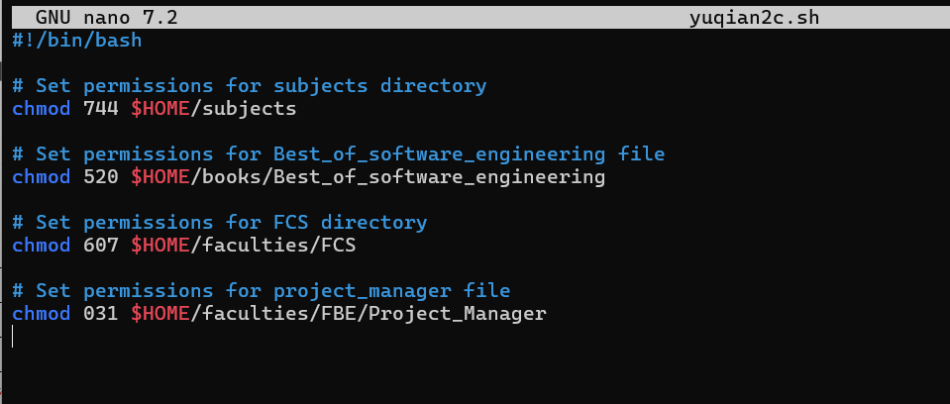

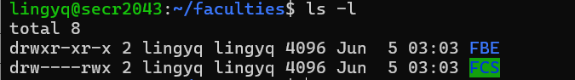

  - Complete the following table by writing the access control for each directory or file after executing the bash script in question 2(c)). [2 marks]

Directory/File | Access Control
subjects | drwxr--r--
Best_of_software_engineering | -r-x-w----
FCS | drw----rwx
project_manager | -----wx--x

End of Lab 3

** * All the Best for Final Exam ***

